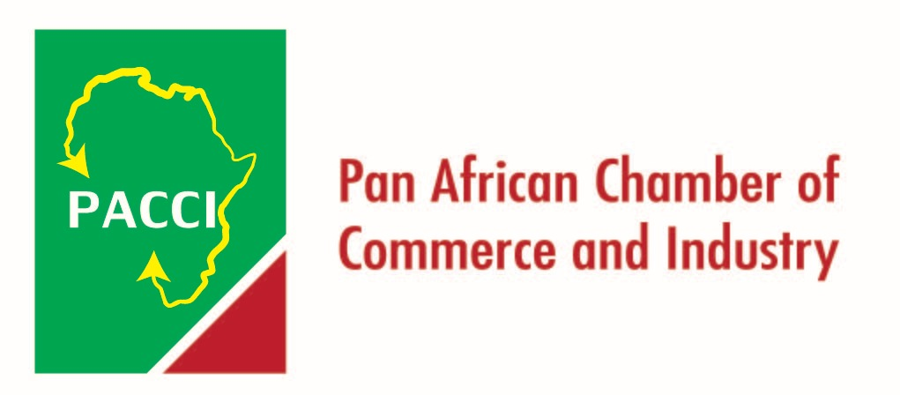
5th AMER CONGRESS
ETHIOPIA

Exhibition & Conference Details

Information:

Date & Time: | Installation & Construction | 26 Sept 2017
 | Exhibitor Move In | 26 Sept 2017
 | Exhibition | 26 –28 Sept 2017
 | Exhibitor Move Out | 29 Sept 2017

Exhibition Venue: UNECA Conference Center (UNECACC) Addis Ababa, Ethiopia

Booth Specification: Standard Shell Scheme of size 3m x 3m. Each standard booth will be provided with signboard area, an information counter a table and two chairs.

Booth Fee: US$ 3000 per booth

Payment: Balance of rental charges/sponsorship fee is due on 01 September, 2017. Acceptance of sponsorship/ exhibition applications will be subject to approval of the Organizer.

Enquiry & Booking: Pan African Chamber of Commerce -PACCI (Organizer)
www.pacci.org, EMAIL info@pacci.org

Remarks: Booth allocations are subjected to Organizer’s discretion. The Organizer on a first-come-first-served basis within the respective sponsorship levels will assign exhibition booths. Customs Clearance and Transportation to the Exhibition are of goods is included in the Booth. This service is complementary to participation at this first Exhibition in Ethiopia.

Payment Method:

- Local companies are advised to settle payment via cheque in US$ payable at

Bank Name: United Bank S.C
Barnch: Hiber branch
Beneficiary: Pan African Chamber of Commerce and Industry
Account number: A/C No. 1421816011739023

- Foreign companies are suggested to settle payment via US dollar cheque, US bank draft or telegraphic transfer.
  - Via US dollar cheque or US bank draft: please make payable to
Bank Name: United Bank S.C
Main branch (IBD)
SWIFT Code – UNTDETAA
A/C No. 36245456 USD
At the Citibank N.A New York
Beneficiary: M/S Pan African Chamber of Commerce and Industry
A/C No. 1021350000285013

  - Via telegraphic transfer:
Bank Name: United Bank S.C
Main branch (IBD)
SWIFT Code – UNTDETAA
A/C No. 36245456 USD
At the Citibank N.A New York
Beneficiary: M/S Pan African Chamber of Commerce and Industry
A/C No. 1021350000285013

Important Notes:

- Whilst every attempt will be made to ensure that all aspects of exhibition and sponsorship mentioned will take place as announced, the Organizer reserves the right to make last minute changes should the need arise.

- The Organizer reserves the right of final decision regarding allocation of exhibition booths.

- Exhibitors are free to select any contractor and/or forwarder at their own discretion. For an efficient and regulated flow inside the convention venue, the Organizer will appoint the official forwarder as a sole forwarder for material transfer. If your company has a local forwarding team, please contact the Secretariat to apply for an exemption.

- The Organizer is not responsible for personal accidents and damage to the private properties of exhibitors. Therefore, exhibitors may wish to make their own arrangements with respect to personal insurance.

Exhibition Floor Plan

Floor plan will be uploaded soon.

Sponsorship Packages

The Organizer welcomes special sponsorship with due acknowledgement in the Final Program Book. Sponsorship is available in the following areas, subject to final approval of the Organizer.

Nature | Sponsorship Amount | Sponsor’s Benefits
Diamond Sponsor | US$50,000 | - 4 Complimentary standard exhibition booths plus preferential treatment regarding placement (subject to availability at the time of booking)  - 3 Complimentary registrations  - Complimentary ½ page color ad in Program Book.  - Company recognized as Diamond Sponsor on Welcome Slide before Oral Presentations.  - Company logo prominently displayed in all Scientific Session marketing materials including Program Book, and event website.  - Company name and logo on the backdrop(s)  - Prominent placement of your company logo on the5th Africa Middle East Region General Research and Exhibition official website with hyperlink to company website  - 4 tickets to attend President’s Reception.  - 10% off additional booth space (after purchase of 1st booth).
Gold Sponsor | US$25,000 | - 3 Complimentary standard exhibition booths (subject to availability at the time of booking.  - 2 Complimentary registrations.  - Complimentary ½ page color ad in Program Book.  - Company recognized as Gold Sponsor on Welcome Slide before Oral Presentations.  - Company logo prominently displayed in all Scientific Session marketing materials including Program Book, and event website.  - Company name and logo on the backdrop(s).  - Prominent placement of your company logo on the 5th Africa Middle East Region General Research and Exhibition official website with hyperlink to company website.  - 3 tickets to attend President’s Reception.  - 10% off additional booth space (after purchase of 1st booth).
Silver Sponsor | US$10,000 | - 2 Complimentary standard exhibition booths.  - 1 Complimentary registration.  - Company recognized as Silver Sponsor on Welcome Slide before Oral Presentations.  - Company logo prominently displayed in all Scientific Session marketing materials including Program Book, and event website.  - Prominent placement of your company logo on the IDAR AMER Congress official website with hyperlink to company website.  - 2 tickets to attend President’s Reception.  - 10% off additional booth space (after purchase of 1st booth).

In-Kind Sponsorship Opportunities

In-kind Sponsorship | Sponsorship Amount | Sponsor’s Benefits
Congress bag (Exclusive) | US$25,000 | - Company name and logo* on the congress bags Satchel insert (one item of promotional material)  - Acknowledgement in the Final Program Book
Name Badge (Exclusive) | US$10,000 | - Company name and logo* on name badges  - Satchel insert (one item of promotional material) Acknowledgement in the Final Program Book
Registration Kit (Folder) | US$3,000 | - Company name and logo* on registration kits  - Satchel insert (one item of promotional material) Acknowledgement in the Final Program Book
Pen | US$3,000 | - Company name and logo* on pens  - Satchel insert (one item of promotional material) Acknowledgement in the Final Program Book
Note Pad | US$3,000 | - Company name and logo* on note pads  - Satchel insert (one item of promotional material) Acknowledgement in the Final Program Book
Polo Shirt | US$10,000 | - All front line helper at the congress will wear specially designed and easily recognizable logo-shirts with the Congress Logo  - Company logo on one sleeve  - Acknowledgement in the Final Program Book
* Priority will be given to Diamond and Gold Sponsors.

Advertising Opportunities

Advertisement# |  | Sponsorship Amount
In Final Program Book or Trade Exhibition Brochure | Back Cover | US$5,000
 | Inside Front Cover | US$4,500
 | Inside Back Cover | US$2,500
 | Inside Full Page | US$3,000
Satchel Insertion |  | US$2,000

Industry –Sponsored Symposium and Speaker Ready Room Sponsorship | Sponsorship Amount
Company logo on signage outside of the room  Company recognized in Program Book( distributed to all attendees)  Company name and/or logo recognized on signage at conference center and sponsor page of the conference website. | US$10,000

Conference Bag Insert | Sponsorship Amount
Opportunity to insert (1) promotional / marketing item in to the conference bags.  500 copies/items must be provided- insert subject to pre-approval by Ethiopian Association for Dental Research. | US$2500

Onsite Advertising Opportunities

Advertising Types |  | Ad Fee (per item)
Overhead Banner Ad (subject to availability) | Overhead hanging banner above exhibitors’ booth  - Banner with two (2) banner hanging points (banner weight: max. 20kg) inside exhibition hall  - Maximum size per banner: 3m x3m  - Subject to availability of hanging points above exhibitors’ booth  - Exhibitors are required to prepare the banner design layout and provide output file on their own.  - Production cost (production by official contractor) is included | $2,000 per unit
Restrooms Oral Hygiene Product Display | Display of oral hygiene products (mouthwash/ toothpaste/ toothbrush/ dental floss) on washing basins inside restrooms of exhibition hall  - Subject to approval by organizer  - Production cost is not included  - Minimum 3basins | $200 per item per basin

Note:
- The Organizer reserves the right to decline any advertisement.
- Reservation of advertisement space will be arranged on “first-come-first-served” basis.
- The Organizer is not responsible for any error, loss, damage or claim resulting from failure of any advertisement.
- Application deadline for in-kind sponsorship, advertising and onsite advertising opportunities: September 1, 2017.
- Deadline for onsite advertisements (escalator and overhead banner) files submission: September 1, 2017.
- Late submission and/ or arrival of material will be liable to omission of advertisement and the cost paid will not be refunded.

Other Sponsorship Opportunities

Others | Sponsorship Amount | Sponsor’s Benefits
Banquet | US$10,000 | - Company name and logo on the backdrop for the 5thAfrica Middle East Region General Research and Exhibition Dinner  - Company name and logo printed on menu  - Acknowledgement on the IDAR AMER Congress official website with hyperlink to company website  - Acknowledgement in the Final Program Book  - Acknowledgement in the banquet  - Satchel insert (one item of promotional material)  - Give away sponsor’s gimmicks / souvenirs duringbanquet
Coffee Break | US$5,000 | - Branding opportunities at the Coffee Break Area (display items subject to mutual agreement with the organizer)  - Acknowledgement on the 5th Africa Middle East Region General Research and Exhibition official website with hyperlink to company website  - Acknowledgement in the Final Program Book
Product Seminar | US$3,000 | - 1.5 hour time slot (sponsorship fee covers venue rental fee and standard audio/visual equipment)  - Details of seminar will be shown on official program  - Limited time slots on a first-come-first-served basis  - Notes:  - Sponsor of this item has to invite and bear honorarium and/or traveling expense of the speaker  - Sponsor can host the product seminar during lunch time but has to arrange and bear additional cost of lunch for attendants
Official Website | US$3,000 | - Banner advertisement on the official website (Note: The width of this ad is at the discretion of the Organizing Committee)  - Acknowledgement in the Final Program Book  - Acknowledgement on the official website with hyperlink to company website  - Satchel insert (one item of promotional material)

Application Form

Please complete and return to PACCI
via Fax: 5th Africa Middle East Region General Research and Exhibition with appropriate payment

CompanyName:
Address:
Contact Person: | Position:
Tel: | Fax:
Email: | Date:
Exhibit BrandName(s):

Exhibition booth(s) request:

1st preference: | US$
2nd preference: | US$
3rd preference: | US$
Amount: | US$

Sponsorship package request:
Diamond sponsor | US$
Gold sponsor | US$
Silver sponsor | US$
Bronze sponsor | US$
Patron | US$
Amount: | US$

In-kind sponsorship opportunities

request:

Congress bag (exclusive) | US$
Name badge (exclusive) | US$
Registration kit (folder) | US$
Pen | US$
Note pad | US$
Polo Shirt for helpers | US$
Amount: | US$

Advertising opportunities request:

Back cover | US$
Inside front cover | US$
Inside back cover | US$
Inside full page | US$
Satchel insertion | US$
Amount: | US$

Onsite Advertising opportunities request:

Escalator Ad – Glass Pane | Quantity: US$
Escalator Ad – Silver Flat | Quantity: US$
Overhead hanging banner above booth | Quantity: Booth No.: US$
Restrooms Oral Hygiene Product Display | Quantity(min.3): US$
Amount: | US$

Other sponsorship opportunities request:
Banquet | US$
Coffee Break | US$
Product seminar | US$
Official website | US$
Internet corner | US$
Amount: | US$
Grand Total: US$/US$
After Discount: (if applicable) US$/US$

THANK YOU FOR YOUR SUPPORT
Terms for Application

PAYMENT AND DEADLINES
- Acceptance of sponsorship applications will be subject to Organizing Committee’s approval. The Organizers Committee reserves the right to decline applications by any association, direct or indirect that does not uphold the objectives of the event.

- 100% deposit payment is due upon submission of this application form. Payment should be made payable to “PACCI BANK ADDRESS.”. Please refer to the previous page for details of payment method. The Organizer will not be responsible for bank handling fees. Hence, please remit payment “Net Charges”. If pay by telegraphic transfer, please attach copy of remittance to PACCI BANK ADDRESS. Balance is due on 1, September 2017.

CANCELLATION POLICY
In the event of withdrawal of sponsorship, please be advised that unless the sponsorship is resold, the Organizer reserves the right to retain money received. All cancellations must be made in writing to info@pacci.org on or before 1, September 2017, 50% of the sponsorship fee will be deducted as administrative expenses. All refunds will be made in 30 days after the event. No refund requests will be entertained after 1, September 2017.

We hereby agree to comply with policies, regulations and rules by the organizers.

Authorized Signature with Company Seal:

